KARNATAKA STATE COUNCIL FOR SCIENCE AND TECHNOLOGY
INDIAN INSTITUTE OF SCIENCE, BANGALORE - 560012
Telephone: 080 – 2334 1652, 2334 8848, 2334 8849, Telefax: 2334 8840
Email: spp@kscst.iisc.ernet.in Website: www.kscst.iisc.ernet.in/spp.html or www.kscst.org.in/spp.html
FORMAT FOR STUDENT PROJECT PROPOSAL
1. | Name of College and Place : B.V.Bhoomaraddi College of Engineering and Technology, Hubli
2. | Name of the SPP coordinator:  Prof. Veeresh B. Angadi  Department of Automobile and Engineering  BVBCET,Hubli  Mobile: 99456-86808
3. | Project title (in brief):  “Med-Auxilliator: Enhancement, Retrieval and Detection of Ailment in MRI scans of Brain”
4. | Department : Computer Science
5. | Name(s) of guide(s) :  Prof. Padmashree Desai.  Associate Professor  Department of Computer Science and Engineering  BVBCET,Hubli  Mobile:
6. | Name of Team Members(5 members) :  Mr. Piyush Singh (piyushksingh2012@gmail.com 9036295013)  Ms. Nirusha Shetty (nirusha157@gmail.com 9916378131)  Mr. Rohit Raj(rohit314@gmail.com 9901162178)  Mr. Suraj Prabhu(surajrp77@gmail.com 9481871177)  Mr. Gagan Purad(kcruzader@gmail.com 9964288388)
6a. | Team Leader of the Project : Mr. Rohit Raj(rohit314@gmail.com 9901162178)
7. | Date of commencement of the Project : 9th September 2012
8. | Probable date of completion of the project : 31st May 2013
9. | Has a similar project been carried out at your college or in any other college / institution (Check with the list of completed projects available in your college library or with the list available at KSCST library, Bangalore). If "Yes", please give details.: NO
10. | If this project is an improvement / extension of an earlier project, please give the title of earlier project and the year in which it was carried out. Specify the improvements / modifications clearly. : NO
11. | Is similar device / machine (outcome of the project) commercially available? If "Yes", what is the cost per unit? Please give details.
12. | Objectives of the project highlighting its importance:  The Purpose of the project is to design a system which enhances the quality of medical scans and has some diagnostic capabilities in order to identify the defect. The proposed system should also retrieve visually similar images for reference.  Objectives  - To extract the features such as colour, texture and shape.  - To transform a discrete image which is defined at one set of coordinate locations to a new set of coordinate points i.e., converting from rectangular to hexagonal grid.  - To enhance the scans of medical images for better visibility.  - To diagnose the ailment.  - To provide visual indication of the affected area.  - To provide a brief description of the problem detected.  - To retrieve images of similar cases for reference.  Abstract: For better diagnostics scientists have been working on the techniques for enhancement of medical images. Gabor filter on hexagonal sampled grid has optimal approximation theoretic performances, for a good quality image. The computational cost is considerably low when compared to similar processing in the rectangular domain. The primary motivation behind using a hexagonal pixel grid model is that retina of the eye closely resembles a hexagonal grid space. The idea is to focus on the analysis of the acquired images, MRI scans of brain, to automate the diagnostic process to some extent.
13. | Methodology:  Logical View  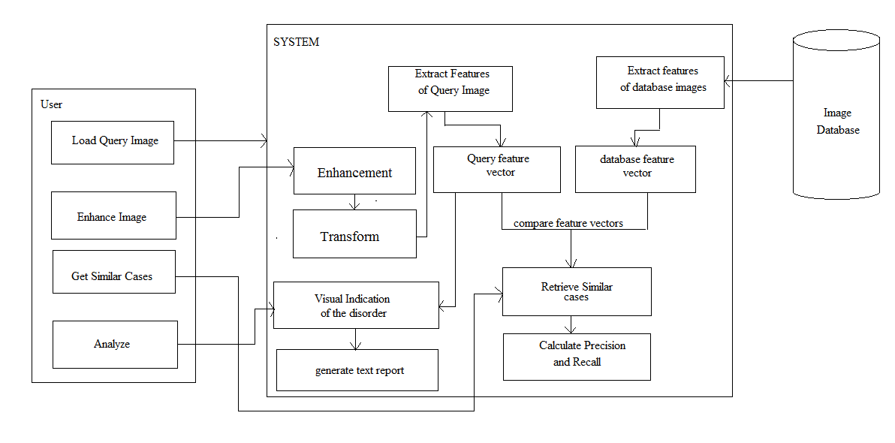  Algorithm  1. Remove noise in the query image using a median filter.  2. The image is resampled to hexagonal grid from the rectangular grid.  The approach followed for resampling is:  for each odd line  find the mid-point between two adjacent pixels by simple linear interpolation.  3. Feature extraction:  Color: Get maximum and minimum pixel value.  Calculate standard deviation, variance and mean.  Texture: Calculate texture parameters using Gray Scale co-occurrence matrix (GLCM)  For calculating GLCM measures for each pixel:  1. Read the input image.  2. Convert the data type to double and Zero pad the image  3. Extract a 3×3 window image from the input image and compute the co- occurrence texture measure  4. Estimate the texture parameters for the obtained texture image  5. Repeat the step3 and step4 by moving the window till the end of the image  6. Display various texture parameters by normalizing them  4. Detection of Edges:  Apply Gabor filter bank for hexagonal sampled grid choosing 3 orientations 0⁰, 60⁰ and 120⁰.  5. Shape: the shapes using moment invariants.  The feature Vector is stored in the database in the following form:  6. Retrieval:  For K-means clustering:  6.1. Initialize cluster centers randomly in texture image  6.2. For all the pixels in the image do the following  a) Compute the Euclidean distance of the feature vector from the cluster for every other cluster.  b) Assign the pixel to that cluster whose center yields the minimum distance from the feature vector  6.3. Update the cluster centers by computing the mean of the feature vectors of the pixels belonging to that cluster  6.4. Between two consecutive updates, if the changes in the cluster centers are less than a specified value, then stop  Else go to step 6.2  7. Similarity comparison: use Euclidean distance for similarity comparison.  8. Defect detection: Use color and texture parameters to identify the defect.  Give Visual indication of the affected area.  Generate text report of the defect.
  Color  Std., variance, mean, max, min | Texture  4X4 = 16 values | Shape  7X4 = 28 values
14. | Expected Outcome of the project:  Retrieval of cases similar to the defect present in the MRI scan of the brain being queried.  Detection of the defect present in the MRI scan of the brain.
15. | Application of the project :  Medical practitioners can use the system for enhancement and analysis of MRI scans of brain.
16. | If the project is a case study / survey project, variables to be studied, criteria for sample selection and size of the sample, etc., should be furnished. A specimen questionnaire should be attached.
17. | In case of fabrication of related project, an engineering drawing with dimensions / detailed design calculations (approximately) of the machine / device should be attached to the proposal.
18. | Budget (break-up details should be given) : __________________________________________________
18. | i. List of materials required and cost : ________________________________________________
18. | ii. List of equipment required and cost : __________________________________________
18. | iii. Labour charges (details to be furnished, at prevailing rates) : ___________________________________
18. | iv. Travel cost required for the project (details such as No. of students / guides & destinations, fare, etc.) _____
19. | Any other details (Please specify) : ___________________________________________________________

Vijayalakshmi M. Prof.K.R.Biradar Dr.Ashok S.Shetter

